Project Planning Phase
Project Planning Template (Product Backlog, Sprint Planning, Stories, Story points)
Date: 07 September 2026
Team ID: B.Santoshi
Project Name: Incident Lifecycle Automation in ServiceNow
Maximum Marks: 5 Marks

Product Backlog, Sprint Schedule, and Estimation (4 Marks)
The following backlog is based directly on the supplied Incident Lifecycle Automation description and its stated key goals.
Sprint | Functional Requirement (Epic) | User Story No. | User Story / Task | Story Points | Priority
Sprint-1 | Incident Creation & Classification | USN-1 | Create and classify incidents | 2 | High
Sprint-1 | Knowledge Management | USN-2 | Search knowledge for faster resolution | 2 | High
Sprint-1 | Assignment & Reassignment | USN-3 | Assign incidents to appropriate support groups | 2 | High
Sprint-1 | Level 2 Investigation | USN-4 | Investigate incidents and record work notes | 2 | High
Sprint-2 | SLA & Escalation | USN-5 | Monitor SLAs and escalate delayed incidents | 2 | High
Sprint-2 | Resolution & Closure | USN-6 | Resolve and close incidents with resolution details | 2 | High
Sprint-2 | Emergency Change | USN-7 | Create emergency change requests from incidents | 2 | Medium
Sprint-2 | Child Incidents | USN-8 | Create child incidents for recurring issues | 2 | Medium
Sprint-2 | Knowledge Article | USN-9 | Generate knowledge articles from resolved incidents | 2 | Medium
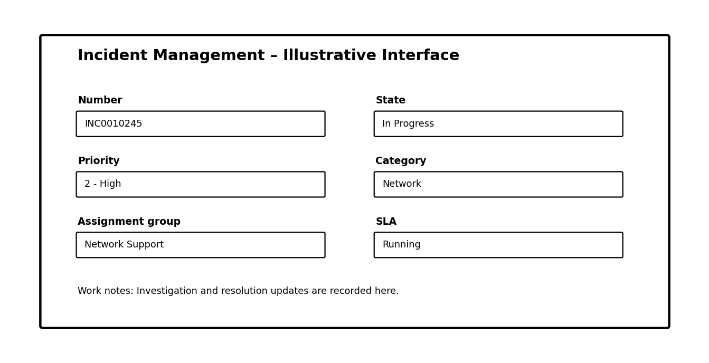
Figure 1: Illustrative incident interface (not a live ServiceNow screenshot).

Project Tracker, Velocity & Burndown Chart
Project: Incident Lifecycle Automation in ServiceNow
Sprint | Total Story Points | Duration | Sprint Start | Sprint End | Completed | Release Date
Sprint-1 | 18 | 5 Days | 07 Sep 2026 | 11 Sep 2026 | 18 | 11 Sep 2026
Sprint-2 | 18 | 5 Days | 14 Sep 2026 | 18 Sep 2026 | 18 | 18 Sep 2026

Velocity
Planned team velocity: 18 story points per sprint. If all planned work is completed, the average velocity across the two sprints is 18 story points per sprint.
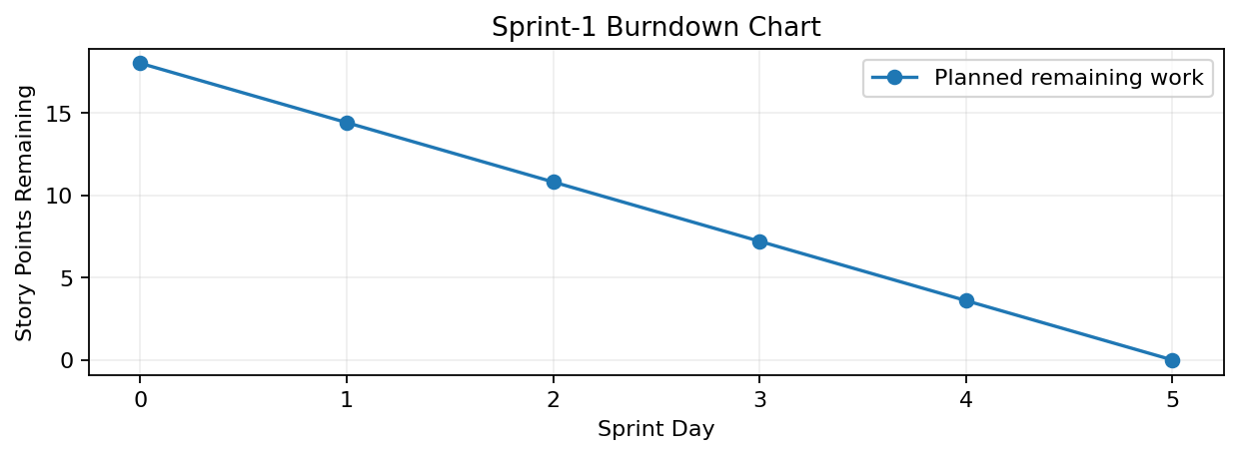
Figure 2: Illustrative Sprint-1 burndown chart. Actual progress should be updated during execution.

Planning Summary
The two-sprint plan covers the stated goals: incident creation and classification, Knowledge Management, reassignment, Level 2 investigation, emergency changes, child incidents, knowledge article generation, and improved SLA visibility.

Incident Lifecycle Automation – Workflow & Architecture
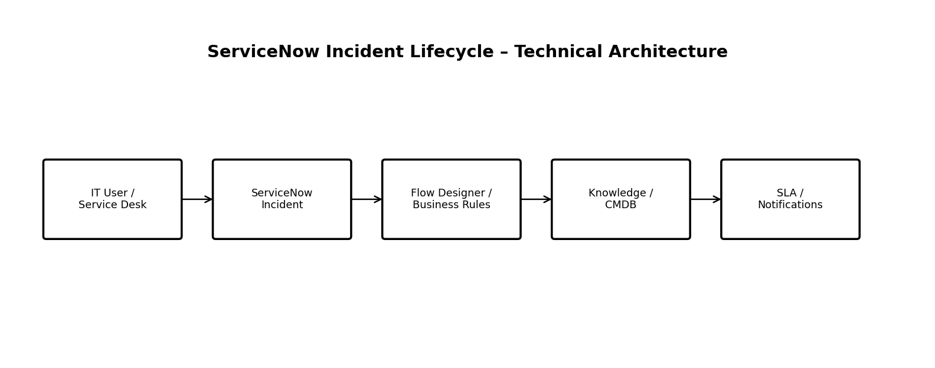
Figure 3: Illustrative technical architecture.
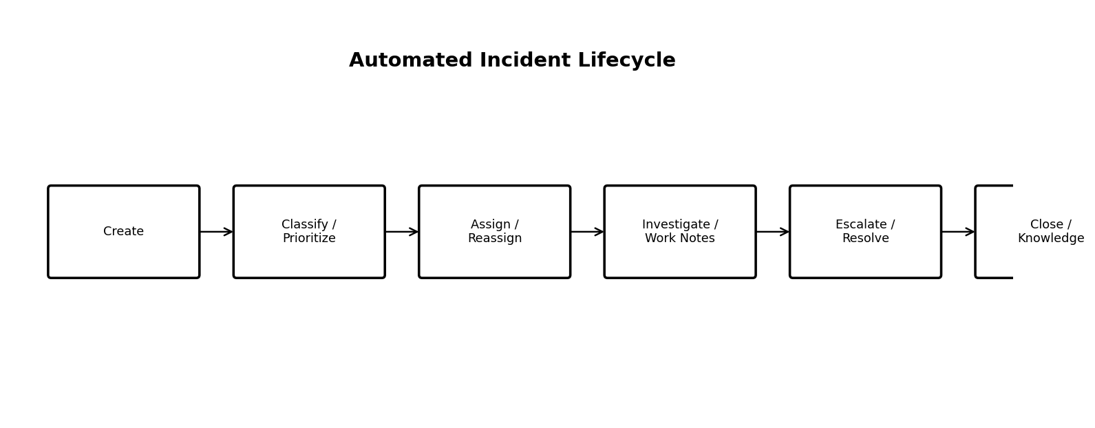
Figure 4: Illustrative automated incident lifecycle.

Expected Outcome
- Standardized incident tracking and classification.
- Faster resolution using Knowledge Management.
- Correct support-group assignment and Level 2 investigation.
- Better SLA monitoring, escalation, and service visibility.
- Support for emergency changes, child incidents, and reusable knowledge from resolved incidents.
Note: Visuals are project illustrations prepared for this document; the uploaded ServiceNow project-images PDF did not contain readable text or image data.

